**Employee Management System**

**Project Report**

Ramanuj Bhattacharya(29)(Backend Creator)

Abhinandan Thakur(59)(GUI Creator)

**Objective**-: This project starts by adding an employee to the database then adding details of project with start and end date. Once, registration is done user can assign projects to the employees. You can also pay the salaries based on the days of work done by the employee. The Main aim of employee Management Mini DBMS project is to ease the management of employees and making their attendance. We aim to demonstrate the use of create, read, update and delete MySQL operations through this project.

**Frontend**-: Java Fx **IDE**- NetBeans Java

**Backend**-: MySQL+ Java

**GUIs**-:5 GUIs New Employee, Assign project , New Project, Attendance, Salary(developed using Java Fx)

Design of GUIs are provided below-: **Add employee**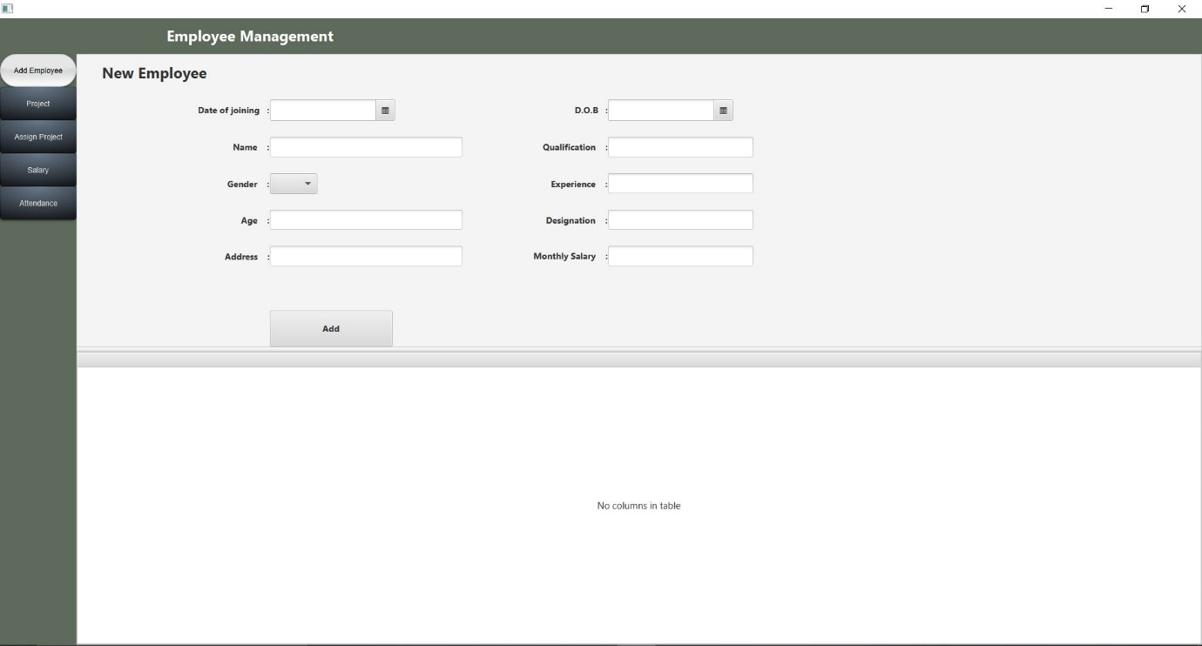

**Attendance**

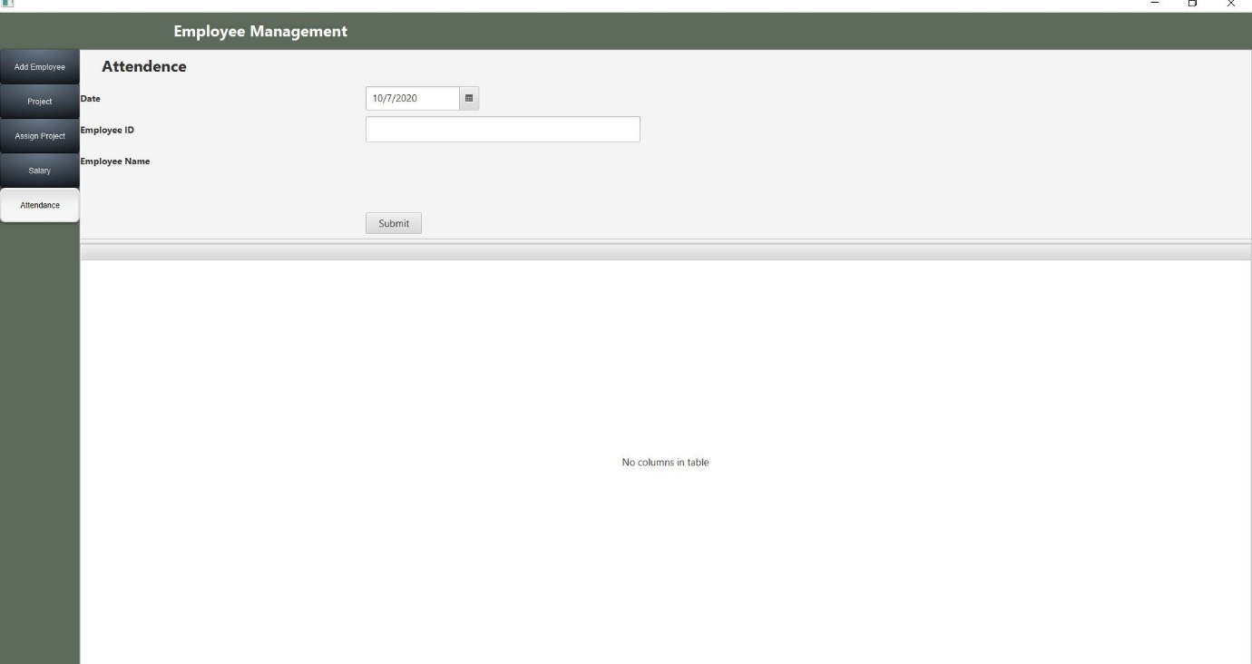

**Assign Project**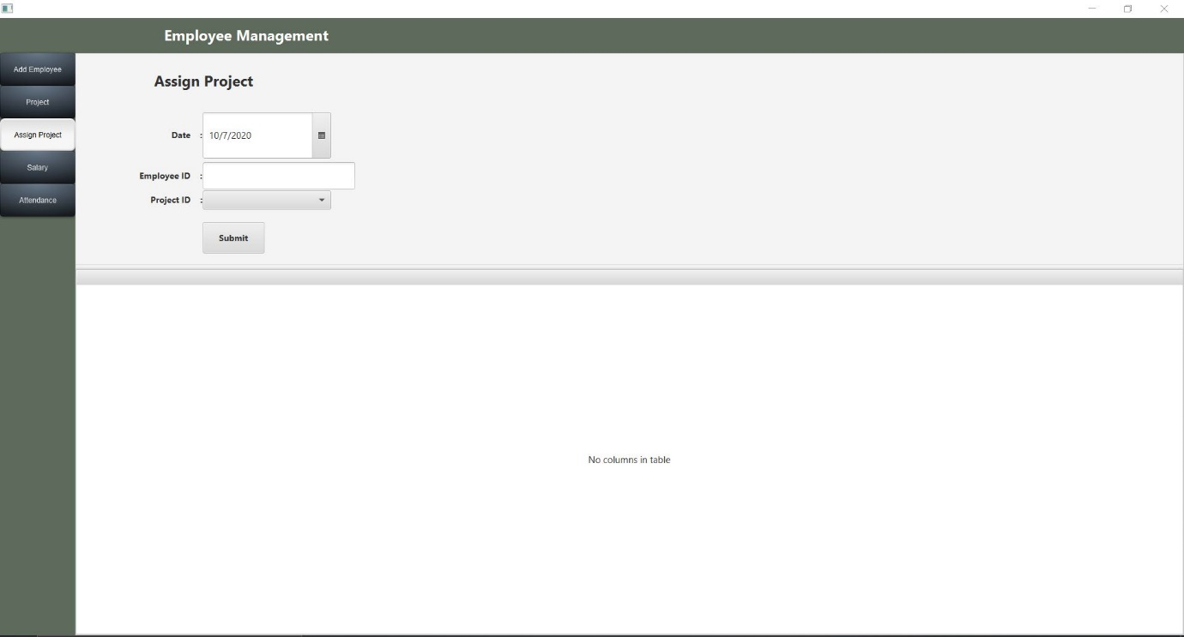

**Salary**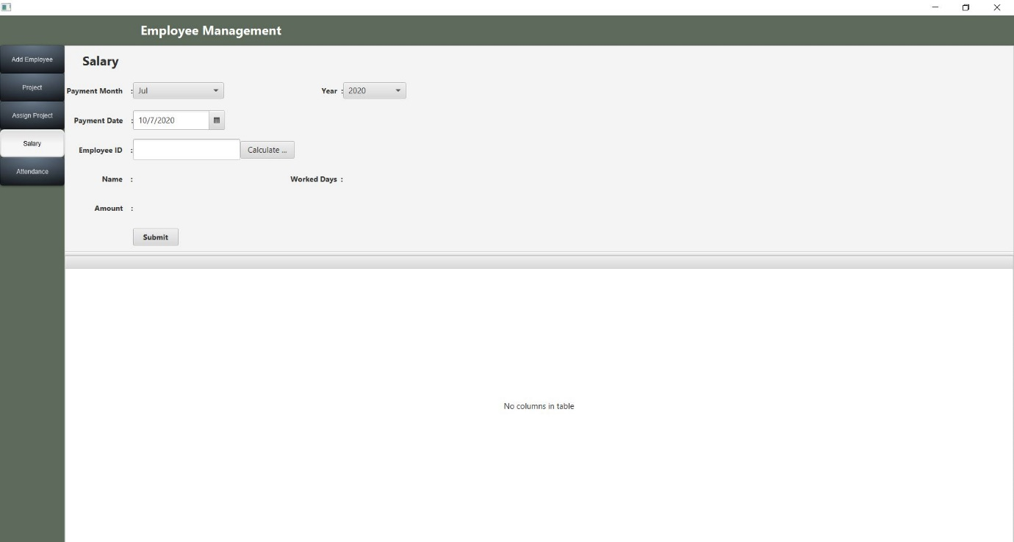

**New Project**

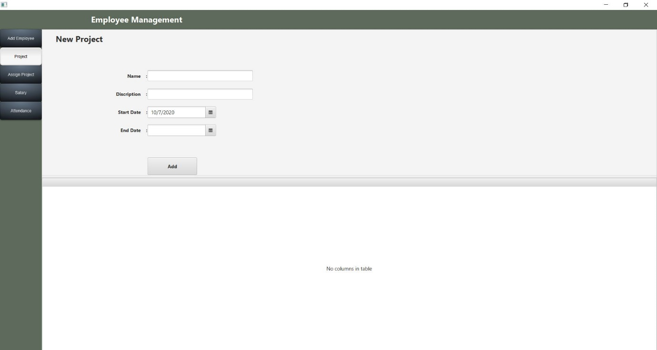

**Schematic view of the Database**

|  |
| --- |
| Employee |
| Id INT(11) |
| Date DATE |
| Name VARCHAR(30) |
| Age INT(11) |
| Gender VARCHAR(10) |
| DOB DATE |
| Address VARCHAR(200) |
| Qualification VARCHAR(30) |
| Exp INT(11) |
| Designation VARCHAR(30) |
| Pay DOUBLE |

|  |
| --- |
| Salary Table |
| Id INT(11) |
| EID INT(11) |
| Date DATE |
| Amount Double |
| PayMonth VARCHAR(30) |
| PayYear INT(11) |

|  |
| --- |
| Attendance Table |
| Id INT(11) |
| Date DATE |
| EID INT(11) |

|  |
| --- |
| Assignment Table |
| Id INT(11) |
| EID INT(11) |
| ProjectName VARCHAR(30) |
| Date DATE |

|  |
| --- |
| Project Table |
| Id INT(11) |
| Name VARCHAR(30) |
| Description VARCHAR(100) |
| StartDate DATE |
| EndDate DATE |

Use Case Diagram of Employee Management System:

HR

Employee

Class Diagram of employee Management System:

|  |
| --- |
| EmployeeManagement Class |
| **Attributes:**  +ID:Int  +Date:DATE  +Name:VARCHAR  +Age:Int  +Gender:VARCHAR  +DOB:DATE  +Address:VARCHAR  +Quaification:VARCHAR  +Exp:Int  +Designation:VARCHAR  +Pay:DOUBLE |
| **Methods:**  +start()  +show()  +main() |

|  |
| --- |
| EmployeeSceneController Class |
| **Attributes:**  +ID:Int  +Date:DATE  +Name:VARCHAR  +Age:Int  +Gender:VARCHAR  +DOB:DATE  +Address:VARCHAR  +Quaification:VARCHAR  +Exp:Int  +Designation:VARCHAR  +Pay:DOUBLE |
| **Methods:**  +initialize()  +addEmployee()  +getFields()  +mDeleteEmp() |

|  |
| --- |
| AttendenceController Class |
| **Attributes:**  +Id:Int  +Date:DATE  +Eid:Int |
| **Methods:**  +initialize()  +submitAttendence()  +bulidTable()  +getEname()  +checkEid()  +attendanceExists() |

|  |
| --- |
| AssignController Class |
| **Attributes:**  +Id:Int  +Date:DATE  +Eid:Int  +ProjectName:VARCHAR |
| **Methods:**  +initialize()  +setAssignment()  +mDeleteAssignment() |

|  |
| --- |
| ProjectSceneController Class |
| **Attributes:**  +Id:Int  +Name:VARCHAR  +Description:VARCHAR  +Startdate:DATE  +EndDate:DATE |
| **Methods:**  +initialize()  +addNewProject()  +mDeleteProct()  +mUpdateProject() |

|  |
| --- |
| SalaryController Class |
| **Attributes:**  +Id:Int  +Eid:Int  +Date:DATE  +Amount:DOUBLE  +PayMonth:VARCHAR  +PayYear VARCHAR |
| **Methods:**  +initialize()  +submitSalary()  +buildTableData()  +calcSal()  +checkEid() |

|  |
| --- |
| MainSceneController Class |
| **Methods:**  +initialize()  +setProject()  +setAssign()  +setSalary()  +setAttendence()  +changeScene()  +setEmployeeScene() |

Object Diagram of Employee Management System

AWS TECH SOLUTIONS Pvt.Ltd

Employment Management System

Project

ID-01

Name- Ayan Sinha

Description- DBMS Workshop Project

Start date- 01.01.20

End Date- 01.06.20

Attendance

ID- 01

Date- 31.05.20

EID- 100

Salary

ID- 01

EID- 100

Date- 31st

Amount- 35000

Month- May

Year- 2020

Employee

ID- 01

Name- Ayan Sinha

DoB-03.07.1995

Age- 26

Ph. No- 9800216735

Qualification- B.Tech(CSE)

Exp- 5yrs

Designation- Database controller

Address- Barasat

Assignment Name

ID- 01

EID- 100

Project name- DTDC Bank Finance Database

Date Assigned- 01.01.20

**Future Implementation of this Mini Project-:**

As a future work some addition stuff should be implemented and integrated into the application code making it much more reliable and flexible . Apparently the role of this system is basic and essential within each company to keep good control and managing the personnel’s records more precisely.

**How to run the Project..!!!!**

The folder we are submitting consists of **1.Report 2.Project zip**. First extract the zip file and then open NetBeans IDE and open the extracted folder in NetBeans and click on the run Button .The project will start running automatically**.**

**THANKING YOU…!!!**